Recon Execution Process

Contents

Run the Datastage Sequence for MA 1

Active Recon Table List 1

Check for the Latest Batch Recon Results 1

Check the Recon Results for the Specific Table and batch 2

Recon Table Entry Sample 2

Run the Recon Datastage Sequence for MA tables 2

Recon Master sequence 2

How to run the Recon Sequence and pass the parameter 2

Recon for Specific Table 3

When to start the Recon Sequence for specific Table 3

How to request the Adhoc DISTCP for specific Table 4

How to run the Recon Sequence for specific table and pass the parameter 4

Specific table parameters 6

Appendix 6

# Run the Datastage Sequence for MA

## Active Recon Table List

SELECT * FROM etl_config.etl_uw_datacompare_table_list WHERE src_sys_nm_nk = 'Marketing' AND table_flag ='Y';

## Check for the Latest Batch Recon Results

To know which we are process are complete, refer the below sql

SELECT edh_created_batch_key, table_name,COUNT(*)

FROM insurance_marketing_conv.marketing_data_compare

GROUP BY edh_created_batch_key, table_name

ORDER BY edh_created_batch_key DESC, table_name;

SELECT * FROM insurance_marketing_conv.marketing_data_compare_summary

WHERE table_name='dim_producer_status';



## Check the Recon Results for the Specific Table and batch

SELECT * FROM insurance_marketing_conv.marketing_data_compare

WHERE edh_created_batch_key='20231009101010' AND table_name='ma_recruiter_contact_details'

For Append and truncate and load table below table needs to be check

insurance_marketing_conv.marketing_Non_nk_data_compare

## Recon Table Entry Sample

(src_sys_nm_nk, source_schema, target_schema, table_name, seq_num, loop_num, table_flag, load_type, apt_config, nk_column_1, nk_column_2, nk_column_3, nk_column_4, nk_column_5, nk_column_6, nk_column_7, nk_column_8, nk_column_9, nk_column_10, nk_column_11, nk_column_12, nk_column_13, nk_column_14, nk_column_15, exclude_columns) VALUES

('Marketing', 'ext_lake_edm_nyledm', 'insurance_marketing_conv_qa', 'ma_channel', '10', '1', 'Y', 'TYPE1', '/opt/IBM/InformationServer/Server/Configurations/4cores.apt', 'chnl_cd_nk', '', '', '', '', '', '', '', '', '', '', '', '', '', '', '')

# Run the Recon Datastage Sequence for MA tables

## Recon Master sequence

SeqPzDataCompareMaster

## How to run the Recon Sequence and pass the parameter

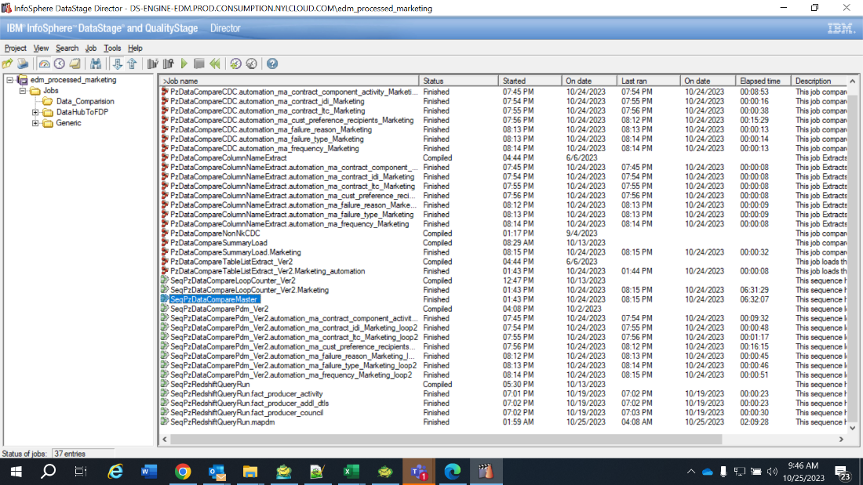===

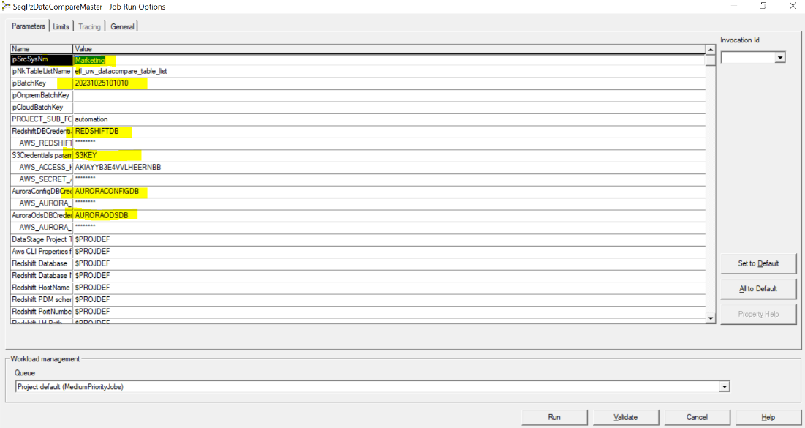

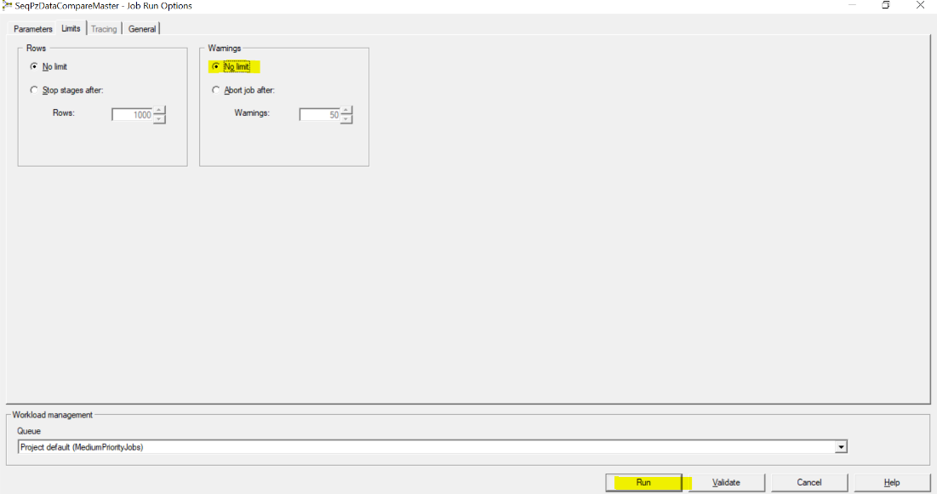

# Recon for Specific Table

## When to start the Recon Sequence for specific Table

Current Date 2023/10/27

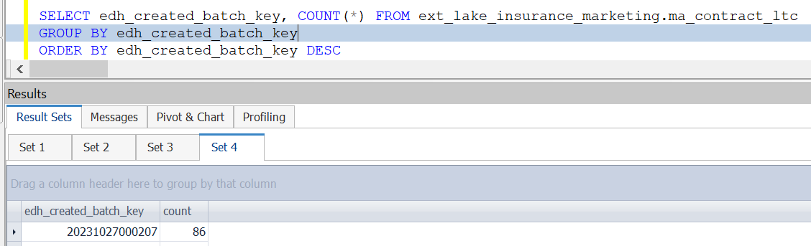

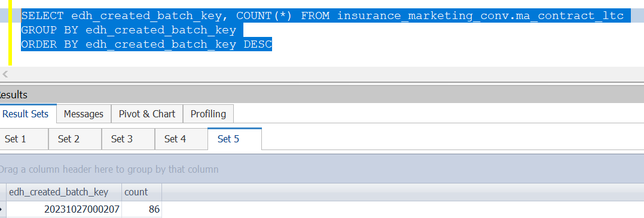

## How to request the Adhoc DISTCP for specific Table

Contact Kowshik Team at offshore

## How to run the Recon Sequence for specific table and pass the parameter

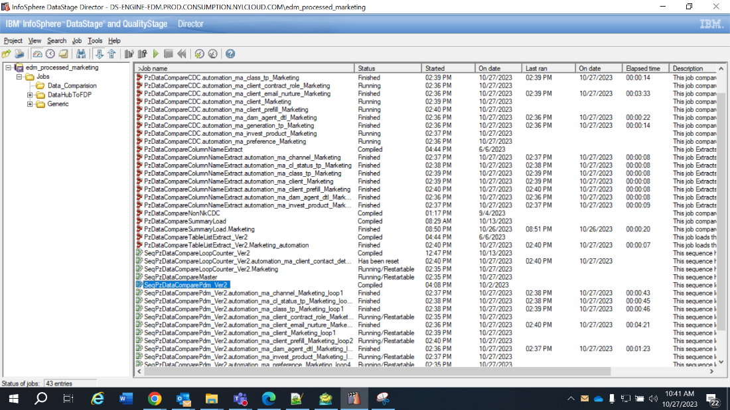

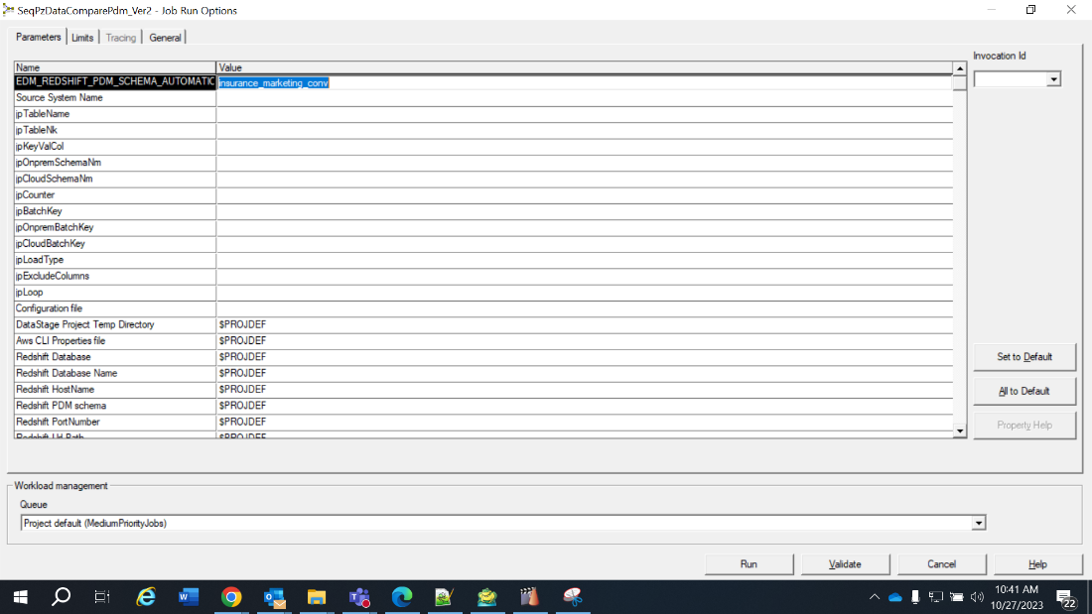

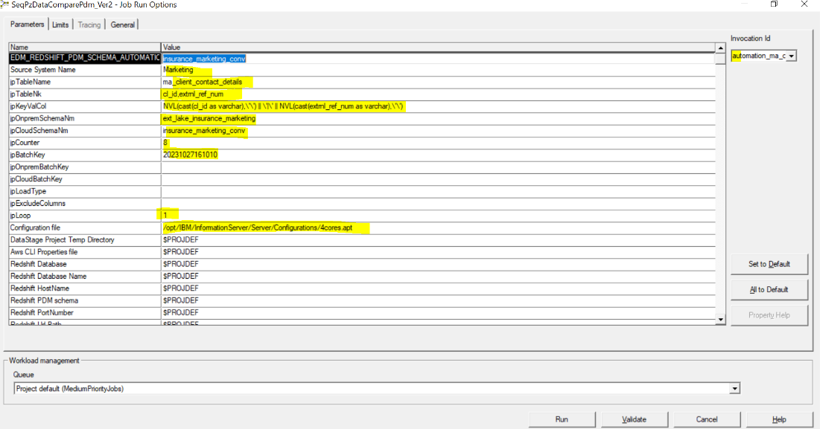

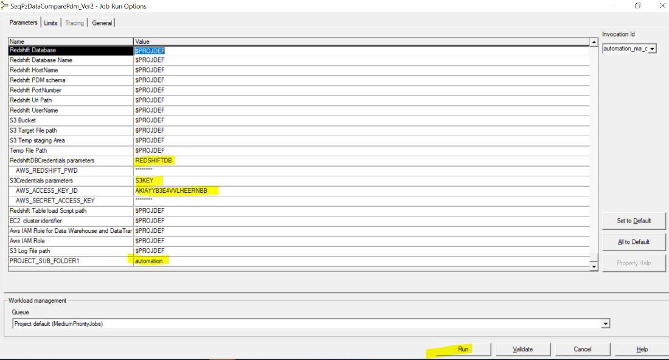

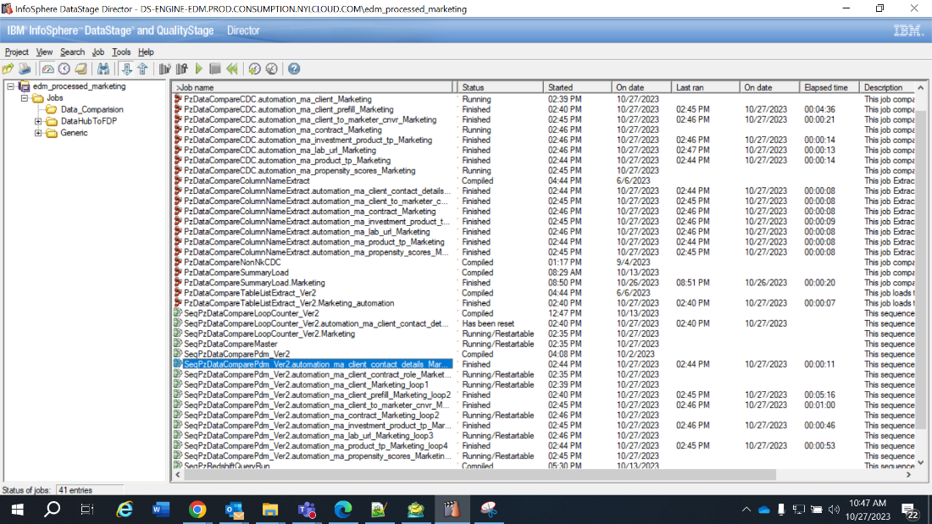

## Specific table parameters



# Appendix

Previous way

SeqPzDataCompareLoopCounter_Ver2

